**Weekly Status Report - 2018-JUNE-19**

|  |  |
| --- | --- |
| **Project Name** | BiFrost Games |
| **Team Lead** | Pat Horler |

|  |  |  |  |
| --- | --- | --- | --- |
| **Roles** |  |  |  |
| **Week** | **<Pat Horler>** | **<Curtis Naples>** | **<Evan Plant>** |
| 01 | Project Lead, Technical Writer | Technical Writer | Technical Writer |
| 02 | Technical Writer, SQL | HTML, SQL | SQL |
| 03 | Front-end Dev, Middleware Dev | Front-end Dev, Middleware Dev | Team Lead, Database Dev, Middleware Dev |
| 04 | Front-end, Middleware Dev | Project Lead, Front-end, Middleware Dev | Front-end, Middleware Dev |
| 05 | Project Lead, Technical Writer, Front-end, Middleware Dev | Front-end, Middleware Dev | Database Dev, Front-end, Middleware |
| 06 | Project Lead, Front-end, Middleware Dev, Technical Writer | Front-end, Middleware Dev, Technical Writer | Database Dev, Front-end, Middleware, Technical Writer |
| 07 |  |  |  |
|  |  |  |  |

|  |  |
| --- | --- |
| **Roles** |  |
| **Week** | **<Devan Weber>** |
| 01 | Technical Writer |
| 02 | Project Lead, SQL |
| 03 | Front-end Dev, Middleware Dev |
| 04 | Front-end, Middleware Dev |
| 05 | Database Dev, Front-end, Middleware |
| 06 | Database Dev, Front-end, Middleware, Technical Writer |
| 07 |  |
|  |  |

|  |
| --- |
| **Weekly Project Summary** |
| Checkout completed and connected to stripe  Created an order history page that saves all orders and allows the user to view them.  Placing an order creates a receipt file to be sent to the customer at a later date  Some CSS and styling improvements |

|  |  |  |  |  |  |
| --- | --- | --- | --- | --- | --- |
| **Key Milestones Status** | | | | | |
| **ID** | **Description** | **Planned Completion** | **Forecasted**  **Completion** | **Actual Completion** | **Status** |
| MS01 | BRD Complete | Week 2 | Week 2 | Week 2 | Complete |
| MS02 | Git Workflow Setup | Week 2 | Week 2 | Week 2 | Complete |
| MS03 | Database Setup | Week 2 | Week 2 | Week 2 | Complete |
| MS04 | HTML/CSS Header Template Complete | Week 2 | Week 2 | Week 2 | Complete |
| MS05 | “Add Products” Page Working | Week 3 | Week 3 | Week 3 | Complete |
| MS06 | Main Product Display Page Working | Week 3 | Week 3 | Week 3 | Complete |
| MS07 | Users Can Create an Account and Sign-in (Including Admin Accounts) | Week 4 | Week 4 | Week 4 | Complete |
| MS08 | Users Can Add Products to Cart and View Them | Week 4 | Week 4 | Week 4 | Complete |
| MS09 | Customer Can Remove/Edit Products In Their Cart | Week 4 | Week 4 | Week 4 | Complete |
| MS10 | Contents of Shopping Carts Persist Across Sessions and Devices | Week 4 | Week 4 | Week 4 | Complete |
| MS11 | Create a file containing the order confirmation that at a future date can be mailed to the client | Week 6 | Week 6 | Week 6 | Complete |
| MS12 | The Online Payment Process Occurs at Checkout | Week 5 | Week 5 | Week 5 | Complete |
| MS13 | Customers Can View Their Order History | Week 6 | Week 6 | Week 6 | Complete |
| MS14 | Website Has a Consistent Look and Feel | Week 6 | Week 6 | Week 6 | Complete |

|  |
| --- |
| **Key Accomplishments for the Week** |
| Order History, Consistent look and feel, electronic payment is smoother, receipts saves to table to be displayed via HTML, and all milestones/requirements accomplished. |

|  |  |  |  |
| --- | --- | --- | --- |
| **Task Assignments for the Coming Week** | | |  |
| **ID** | **Description** | **Assigned To** | **On Schedule** |
| T44 | Power Point Presentation | Devan, Evan | Yes |
| T45 | Project Specifications | Devan, Evan, Curtis, Pat | Yes |
| T46 | Usability Guide | Devan, Evan, Curtis, Pat | Yes |
| T47 | Problems and Challenges | Devan, Evan, Curtis, Pat | Yes |
| T48 | Lessons Learned | Devan, Evan, Curtis, Pat | Yes |
| T49 | WWYD Differently | Devan, Evan, Curtis, Pat | Yes |
| T50 | Sample Code | Devan, Evan, Curtis, Pat | Yes |
| T51 | Peer Reviews | Devan, Evan, Curtis, Pat | Yes |
| T52 | Weekly Task Report | Pat | Yes |
|  |  |  |  |

|  |  |  |
| --- | --- | --- |
| **Task Completed in the Previous Week** | |  |
| **ID** | **Description** | **Assigned To** |
| T37 | Billing and Order Info writes to HTML file | Devan, Evan |
| T38 | Display previous orders to page | Curtis, Pat |
| T39 | Receipt table creation | Devan, Evan |
| T40 | Final Adjustments to CSS | Pat, Curtis |
| T41 | Weekly Task Report | Pat |
|  |  |  |
|  |  |  |
|  |  |  |
|  |  |  |
|  |  |  |
|  |  |  |

|  |  |
| --- | --- |
| Issues and Risks |  |
|  | **Impact**  **(L,M,H)** |
| Repository becomes corrupt | M (we have offline backups) |
|  |  |
|  |  |

|  |
| --- |
| **Gantt Chart** |

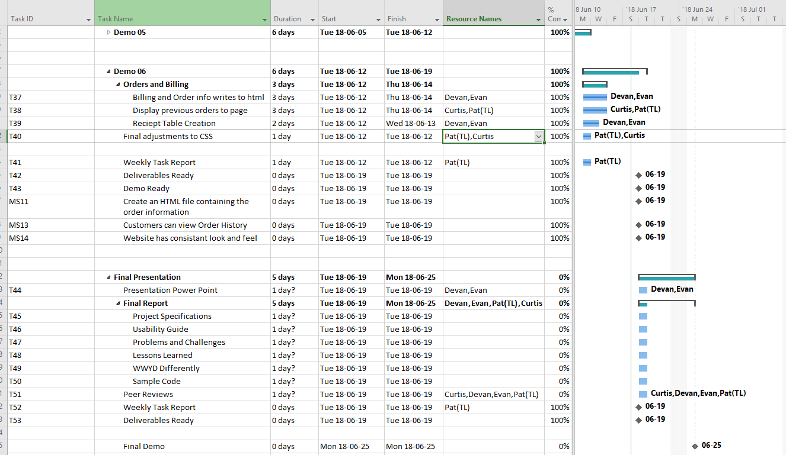

|  |
| --- |
| **Git Log** |

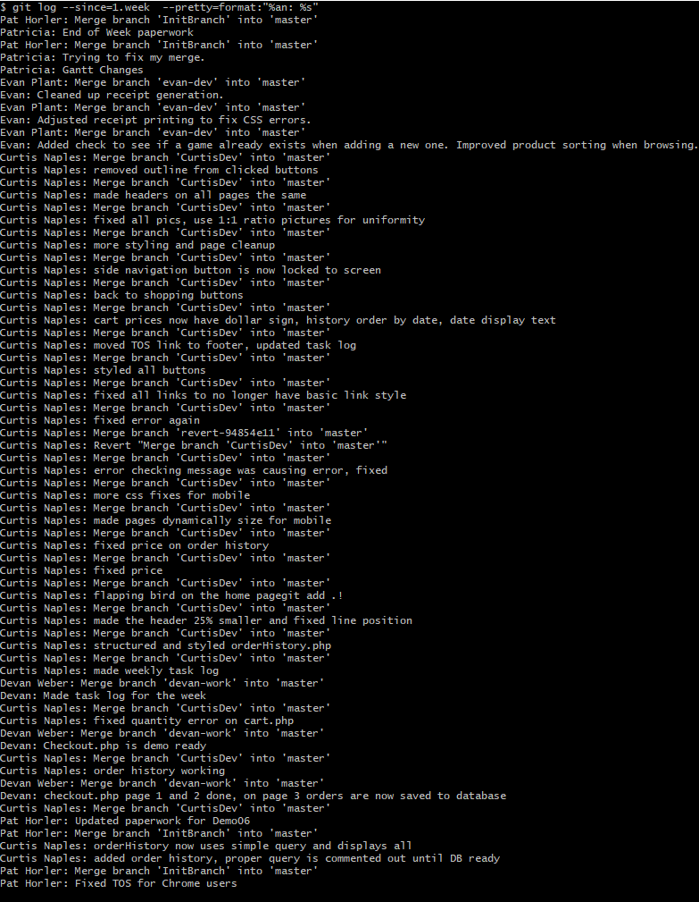*< Insert Git Log here, use the following command git log --since=1.week --pretty=format:"%an: %s">*